

**CL**



**-**



**2006**



**Operating**



**System**



**LAB**

**-**

**04**



**System Calls Related to Process**

**Control**

**National University of Computer and Emerging Sciences**

**Spring 2024**

# OBJECTIVE

The objective of this lab is to learn about Linux process management, commands to see running processes, system call to create processes, get their IDs, and wait and exec system call and to learn about zombie and orphan processes.

# CONCEPTS

## Linux Processes

A Linux process or task is known as the instance of a program running under Linux environment. This means that if 10 users from servers are running gedit editor, then there are 10 gedit processes running on the server. Although they are sharing same executable code. The processes running in a Linux system can be view using ‘ps’ command which we covered.

## Process ID

In Linux system, each process running has been assigned a unique ID which is known as PID (Process Identification Number). For example, Firefox is a running process if you are browsing the internet. Each time you start a new Firefox browser the system will automatically assign a PID to the new process of Firefox. A PID is automatically assigned when a new process is created on the system. If you wish to find out the PID of the running process like Firefox you may use the command ‘pidof’.

$ pidof firefox

$ pidof bash

$ pidof bioset

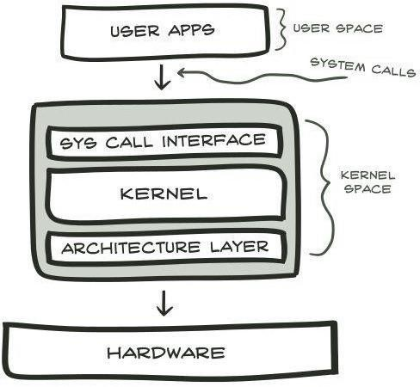To view the running process in a form of a tree we can use ‘pstree’ command. Which shows the running process in a form of a tree.

## Process Management

In general, a process is an instance of a program written and compiled. There can be multiple instances of a same program. In other words, a program that is loaded into computer’s memory and is in a state of execution is called a process. Processes are dynamic entity. Process essentially requires CPU and RAM resources but may also require I/O, Network or Printer depending on the program written.

## System Calls

A **system call** is a mechanism that provides the interface between a process and the operating system. It is a programmatic method in which a computer program requests a service from the kernel of the OS. System call offers the services of the operating system to the user programs via API (Application Programming Interface). System calls are the only entry points for the kernel system.

## Architecture of the System Call

Given System Call example diagram.

**Step 1)** The processes executed in the user mode till the time a system call interrupts it.

**Step 2)** After that, the system call is executed in the kernel-mode on a priority basis.

**Step 3)** Once system call execution is over, control returns to the user mode.,

**Step 4)** The execution of user processes resumed in Kernel mode.

## Types of System Calls

Here are the five types of System Calls in OS:

1. Process Control
2. File Management
3. Device Management
4. Information Maintenance
5. Communications

|  |  |
| --- | --- |
| **Process Control**  This system calls perform the task of process creation, process termination, etc.  **Functions:**   1. End and Abort 2. Load and Execute 3. Create Process and Terminate Process 4. Wait and Signal Event 5. Allocate and free memory. | **File Management**  File management system calls handle file manipulation jobs like creating a file, reading, and writing, etc.  **Functions:**   1. Create a file 2. Delete file 3. Open and close file 4. Read, write, and reposition 5. Get and set file attributes |
| **Device Management**  Device management does the job of device manipulation like reading from device buffers, writing into device buffers, etc.  **Functions:**   1. Request and release device 2. Logically attach/ detach devices. 3. Get and Set device attributes | **Information Maintenance**  It handles information and its transfer between the OS and the user program.  **Functions:**   1. Get or set time and date 2. Get process and device attributes |
| **Communication:**  These types of system calls are specially used for inter-process communications.  **Functions:**   1. Create, delete communications connections 2. Send, receive message 3. Help OS to transfer status information 4. Attach or detach remote devices | |

## Summary of System Calls

|  |  |  |
| --- | --- | --- |
| **Categories** | **Windows** | **Unix** |
| Process control | CreateProcess()  ExitProcess()  WaitForSingleObject() | fork() exit() wait() |

SetConsoleMode() loctl()

Device manipulation ReadConsole() read()

WriteConsole() write()

|  |  |  |
| --- | --- | --- |
| File manipulation | CreateFile()  ReadFile()  WriteFile()  CloseHandle() | Open() Read() write() close!) |

GetCurrentProcessID() getpid()

Information maintanence SetTimer() alarm()

Sleep() sleep()

|  |  |  |
| --- | --- | --- |
| Communication | CreatePipe()  CreateFileMapping()  MapViewOfFile() | Pipe() shm_open() mmap() |

SetFileSecurity() Chmod()

Protection InitlializeSecurityDescriptor() Umask()

SetSecurityDescriptorGroup () Chown()

### System Call Related to Process

There are a lot many Linux system calls available inbuilt for the users. A system call is as good as a function in C Programming Language. It can be compared with ‘printf’ function in C. The reason that it is often called system call rather than functions is that functions are limited to programming while system calls are specific for operating systems.

These system calls perform the task of process creation, process termination, etc. The Linux System calls under this are fork() , exit() , exec(). Some of these are

**1. fork() 2. exec() 3. exit()**

### Fork System Call

In Linux, process is created by duplicating parent process. This is called forking. You invoke the fork system call with fork() function. Usually A new process is created by the fork() system call. Process may be created with fork () without a new program being run-the new sub-process simply continues to execute exactly the same program that the first (parent) process was running. It is one of the most widely used system calls under process management.

### Definition

It is a system call that creates a new process under Linux operating system. It takes no argument. The purpose of fork() is to create a new process which becomes the child process to the caller. After the new child process is created, both processes will execute next instruction following the fork system call, therefore we have to distinguish the parent process from the child which can be done by evaluating the returned value of fork() function.

By examining the returned value of fork function, we can can determine the current process is parent or child process. following are the returned value and their meaning. If the returned value is negative, it means that the child process creation was unsuccessful. If the returned value is zero, the child process is created with pid = 0. If the returned value is positive, the child process is created with the process with a process ID to the parent process. The returned process ID is of type pid_t defined in sys.type.h). Normally this process ID is an integer.

After the system call to fork() is issued, a simple test can tell which process is the child. Note that Linux will make an exact copy of the parent address space and give it to the child. Therefore, the parent and child processes have separate address space. Consider the following C language program:

# EXCERCISES

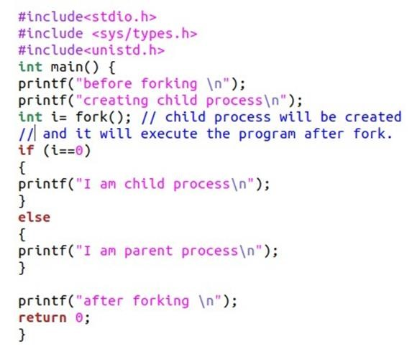

## Example

Implement the above code and check the output. **Compilation of program:**

**gcc -o obj filename.c**

**./obj**

**Example for ‘fork()’ Distinguishing Parent and Child**

When the main program executes fork(), an identical copy of its address space, including the program and all data, is created. System call fork() returns the child process ID to the parent and returns 0 to the child process. The images below will diagrammatically show the above code execution of forking:

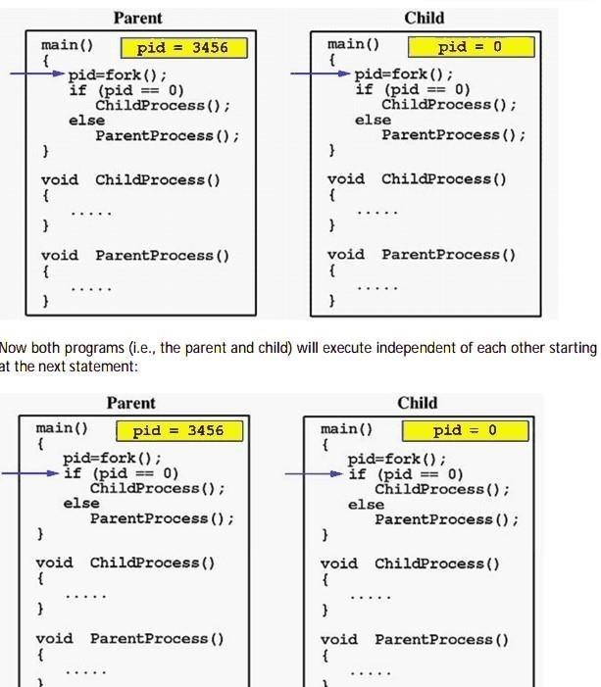

In the above image, the fork function is called, which creates a new process and assign value of pid in parent process and assign 0 in child process. During if condition, it checked if the pid is zero or not to distinguish between parent and child process and invoke the functions of each process respectively.

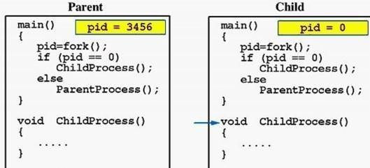

Due to the fact that the CPU scheduler will assign a time quantum to each process, the parent or the child process will run for some time before the control is switched to the other and the running process will print some lines before you can see any line printed by the other process. The following codes distinguishes parent and child process working on variable in shared and separate address spaces: Even though the variable name remain same in child process yet due to separate address of process the variable is considered a new variable in process.

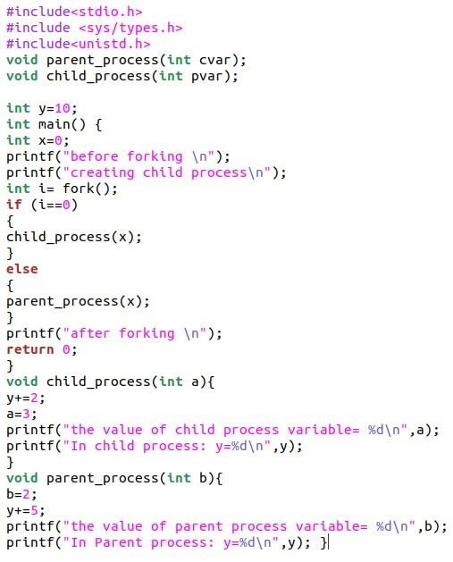

Implement the above program and check the output:

## System Call to Get Process IDs

There are two system calls (functions) which can get the Process ID one is to get the process ID of the current process and another one to get the ID of its parent process. These are:

* ‘getpid()’ returns the PID of current process
* ‘getppid()’ returns the PID of parent’s process

**Task:** In the above example print the process ID of parent and child process and their parent processes plus child process should also print his her grand parent process id.

**Multiple child process:**

In the following example multiple child are created . The execution sequence may be different in your system as compare to the commented sequence of print.

Execute the program and verify the creation of multiple child. Understand the tree.

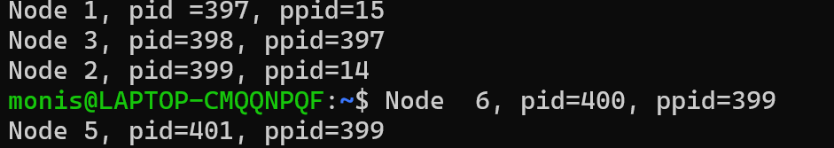 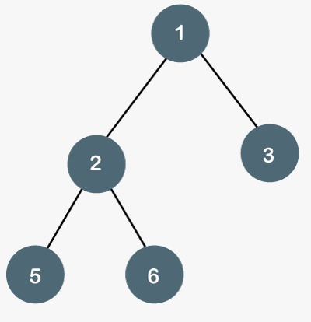

## Different Kinds of Child Process • Zombie Process

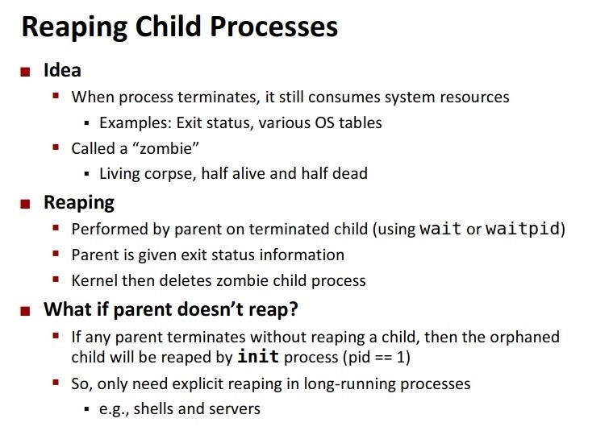

Implement the below program and check the output by opening two terminals. In one terminal, you need to execute your zom.c program and in second terminal execute **ps -a** to check the status of child process. As given below. Then find the parent process id and kill the child process.

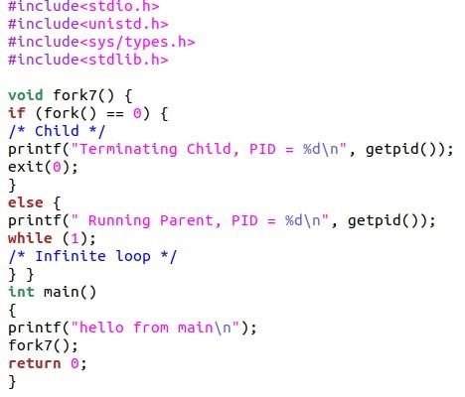

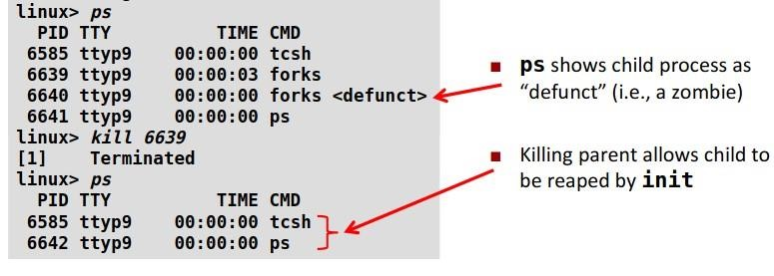

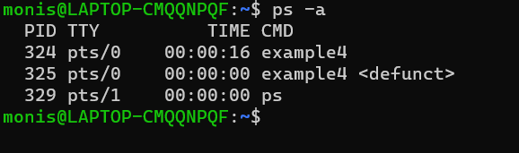

**Solution to Avoid Creation of Zombie Processes**

Using wait() system call we can avoid the creation of zombie process. The below changes to the above code will force the parent to wait:

|  |  |
| --- | --- |
| **Parent without WAIT();** | **Parent with WAIT():** |

What happens when the main make-zombie program ends when the parent process exits, without ever calling wait? Does the zombie process stay around? No—try running ps again, and note that both of the make-zombie processes are gone. When a program exits, its children are inherited by a special process, the init program, which always runs with process ID of 1 (it’s the first process started when Linux boots).The init process automatically cleans up any zombie child processes that it inherits. Implement the above program and check the output.

**Orphan Process:**

In general English terms, orphan is someone who lost parents. Same is the story here. If the parent process has finished execution and exited, but at the same time if the child process remains UN-executed, the child is then termed to be an orphan. This is done by making the child process sleep for sometimes. By that time of child’s sleep, parent process will complete its execution and will exit. Since, parent process is no more there, child is referred to be an orphan now.

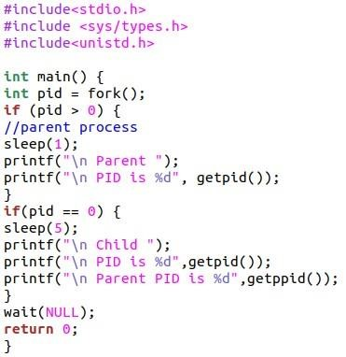

Implement the given below program and check the child process with ps -al command.

**Task:** As you do not see child process therefore, us wait system call to the program and again check the successful execution and return of child to parent.

### Execute System Call ‘exec’

Fork allow you to create a process by duplicating the process of the current program, that is from whom it is called. However, limitation arises when you wish to execute a different program and this is where execute system call come in handy!

The **exec()** family of functions creates a new process image from a regular, executable file. This file is either an executable object file, or an interpreter script. There is no return from a successful call to an exec() function, because the calling process is functionally replaced by the new process.

In other words A new program will start executing after a call to exec(). Running a new program does not require that a new process be created first: any process may call exec() at any time. The currently running program is immediately terminated, and the new program starts executing in the context of the existing process.

The arguments specified by a program with an exec() function are passed on to the new process image in the corresponding main() arguments.

int execl(const char *path, const char *arg0, .., const char *argn, (char *)0); **path:** Specifies the path name of the new process image file.

**arg0, ..., argn:** Point to null-terminated character strings. These strings constitute the argument list for the new process image. The list is terminated by a NULL pointer. The argument arg0 should point to a file name that is associated with the process being started by the exec() function.

**Last argument:** is passed null as the function passes string.

The exit() system call is used by a program to terminate its execution. The operating system reclaims resources that were used by the process after the exit() system call.

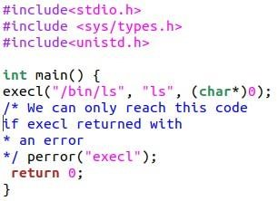

Execute the above code , you should get output of current directory files.

To avoid the replacement of current process, we can use fork and create child process which will be executing the other execution units.

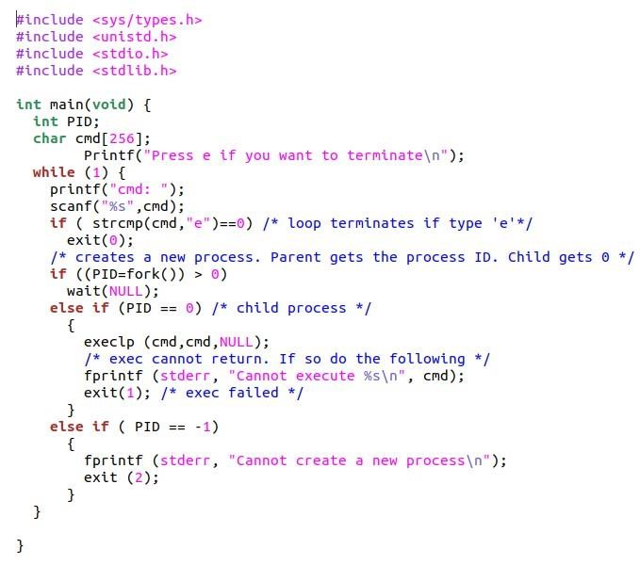

Execute the above example and find the output, understand how it works.

**Exercises:**

1.Write a program that accomplish the following purpose:

a) Call the system call to create the child process and store the value returned from the call.

b) If the returned value is less than zero,

1. Print ‘Unsuccessful Child Process Creation “and Terminate using exit system call

2.If the return value is greater than zero

a)Add a wait system call so that the parent would wait for child process to complete.

3.If the return value is equal to zero

a)Print the parent ID and Make a loop to prints odd numbers from 1 - 10 c)Print “Child Ends”

1. Write a Program that Creates n-child process from same parent process using fork() in C
2. Write Program to create four processes (1 parent and 3 children) where they terminate in a sequence as follows:
   * 1. Parent process terminates at last.
     2. First child terminates before parent and after second child.
     3. Second child terminates after last and before first child. (d) Third child terminates first.
3. Write a program which creates processes 4 processes for parallel programming. Each parent will wait for the termination of its child.
4. Write a C program that creates child processes as many times as user wants until user inputs.

zero (use while loop). Also display process id of each child process.

1. Implement the following 9 tree structure. Each node must print its name and PID. e.g. I am Process A and my PID is 2453

